Thermistor
# Source: AI Source: Provided by: [Data Path: Persons Table -> ID Column: 1, Name_En Column: Motasem Essam] -> From: [ChatGPT] on [7/17/2026]
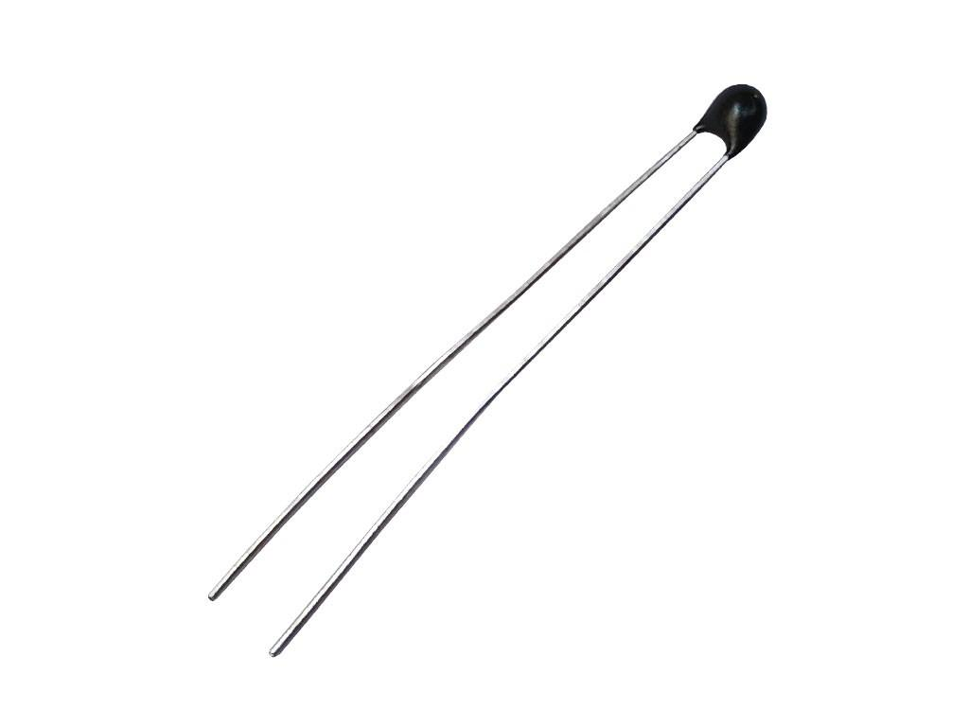
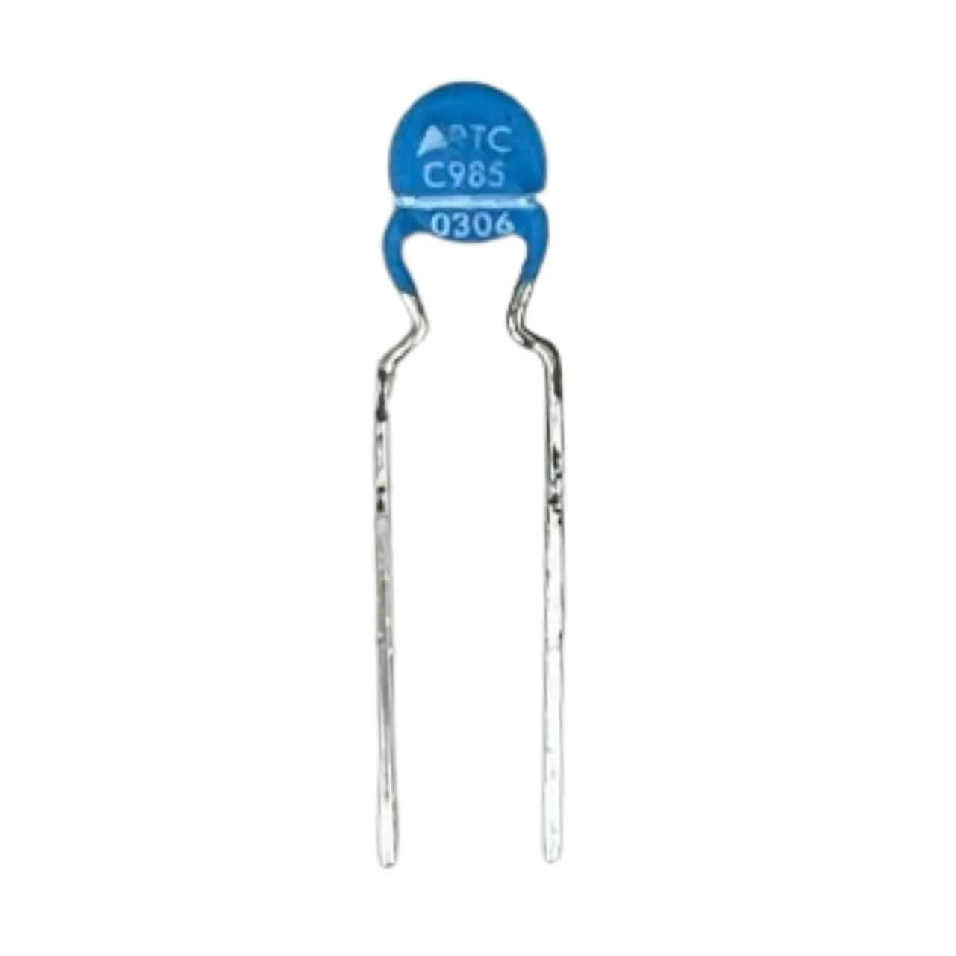

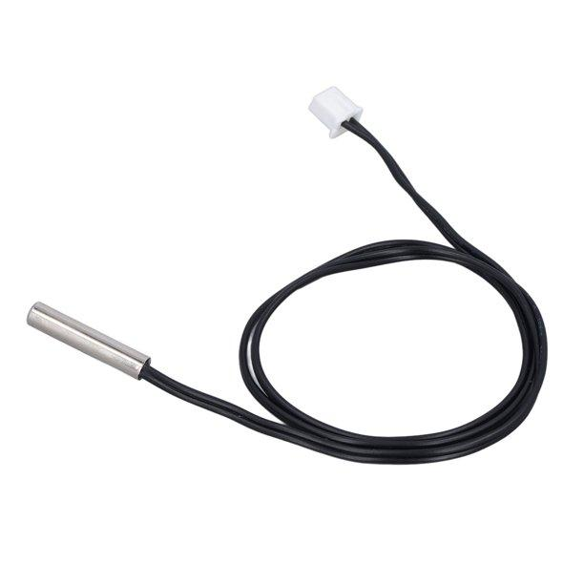
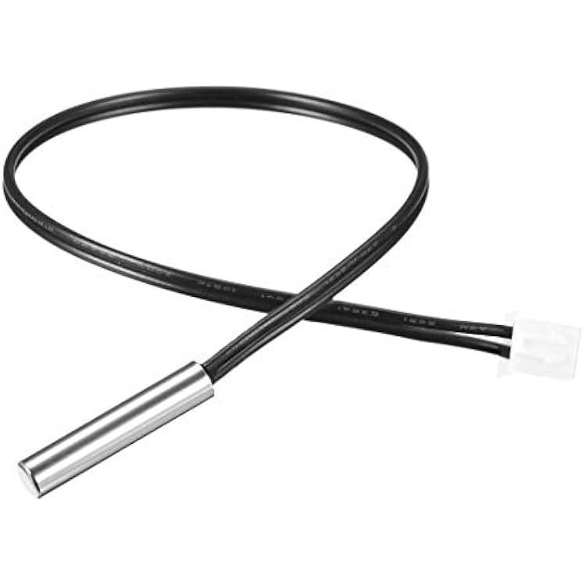
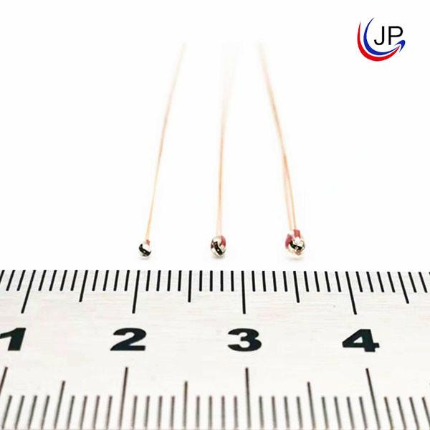
A Thermistor is a temperature-sensitive resistor whose electrical resistance changes significantly with temperature. It is one of the most widely used electronic temperature sensors due to its high sensitivity, fast response, and low cost.
Thermistors are commonly found in digital thermometers, medical equipment, automotive systems, household appliances, industrial control systems, and electronic devices.

Definition
# Source: AI Source: Provided by: [Data Path: Persons Table -> ID Column: 1, Name_En Column: Motasem Essam] -> From: [ChatGPT] on [7/17/2026]
A Thermistor is a resistor whose resistance changes predictably with temperature, allowing temperature to be measured electronically.

Purpose
# Source: AI Source: Provided by: [Data Path: Persons Table -> ID Column: 1, Name_En Column: Motasem Essam] -> From: [ChatGPT] on [7/17/2026]
A thermistor is used to:
- Measure temperature.
- Monitor temperature changes.
- Control heating and cooling systems.
- Protect electronic circuits from overheating.
- Provide temperature feedback for automatic control systems.

Principle of Operation
# Source: AI Source: Provided by: [Data Path: Persons Table -> ID Column: 1, Name_En Column: Motasem Essam] -> From: [ChatGPT] on [7/17/2026]
A thermistor works because its electrical resistance changes with temperature.
- As temperature changes,
- Resistance changes,
- Electronic circuits convert the resistance into a temperature reading.

Main Components
# Source: AI Source: Provided by: [Data Path: Persons Table -> ID Column: 1, Name_En Column: Motasem Essam] -> From: [ChatGPT] on [7/17/2026]
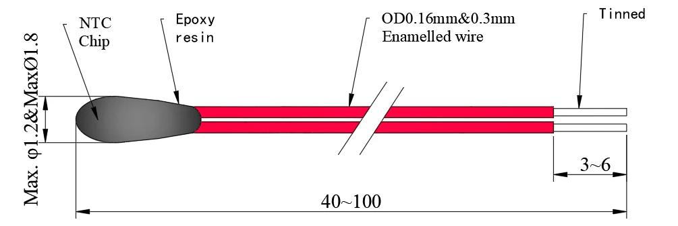
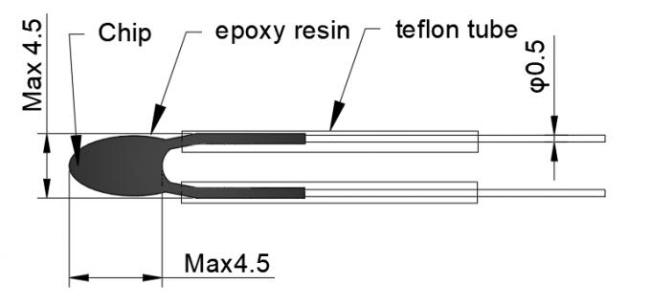
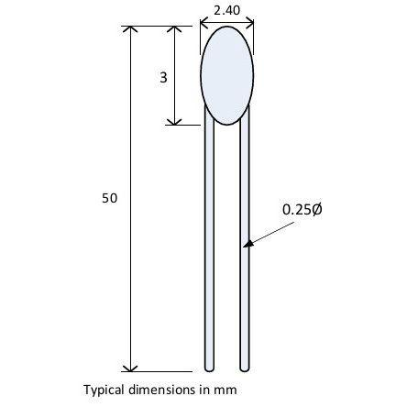
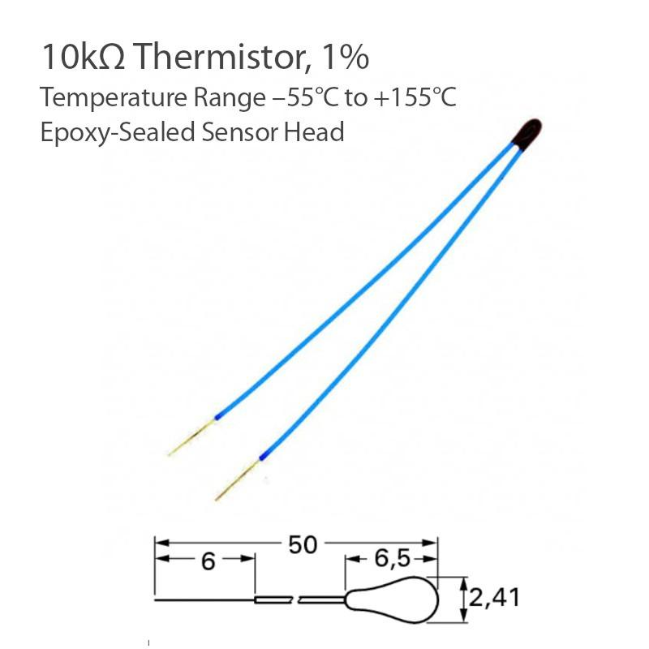
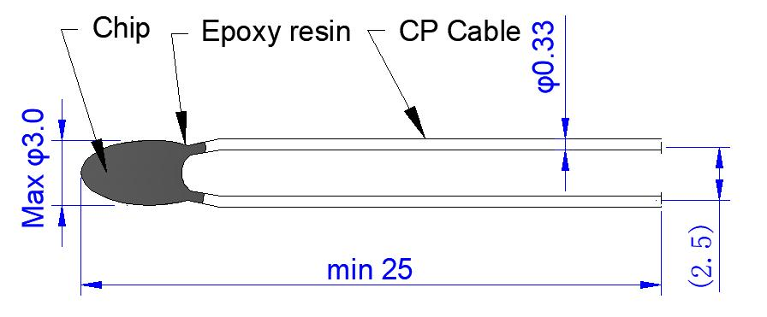
A thermistor typically consists of:
- Semiconductor sensing element
- Protective coating or glass bead
- Lead wires
- Electrical insulation
- Probe housing (for probe models)

Types of Thermistors

1. NTC (Negative Temperature Coefficient)
# Source: AI Source: Provided by: [Data Path: Persons Table -> ID Column: 1, Name_En Column: Motasem Essam] -> From: [ChatGPT] on [7/17/2026]

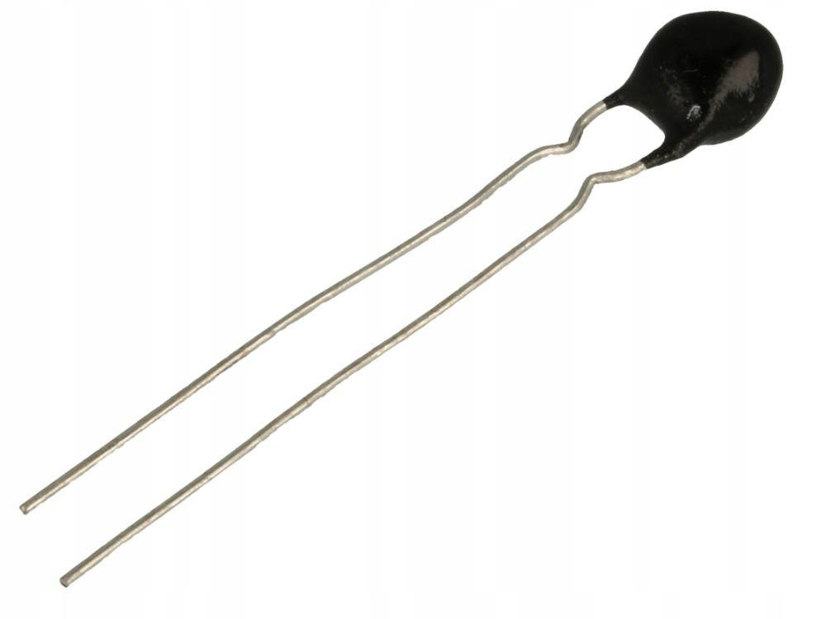
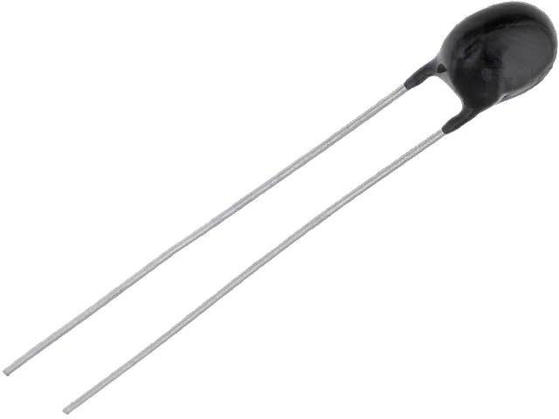

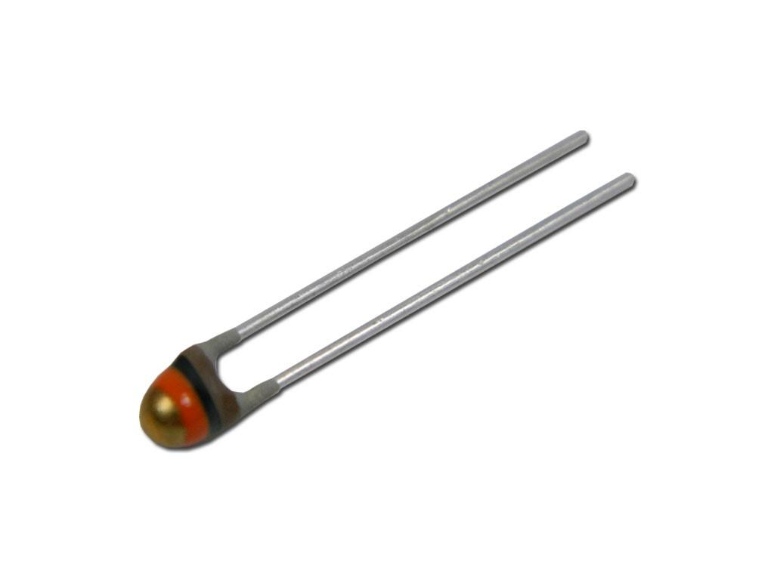
Description
Resistance decreases as temperature increases.
Features
- High sensitivity
- Fast response
- Most common type
Applications
- Digital thermometers
- Air conditioners
- Refrigerators
- Medical devices

2. PTC (Positive Temperature Coefficient)
# Source: AI Source: Provided by: [Data Path: Persons Table -> ID Column: 1, Name_En Column: Motasem Essam] -> From: [ChatGPT] on [7/17/2026]
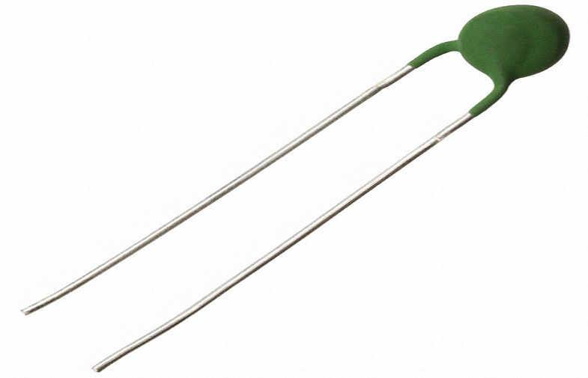
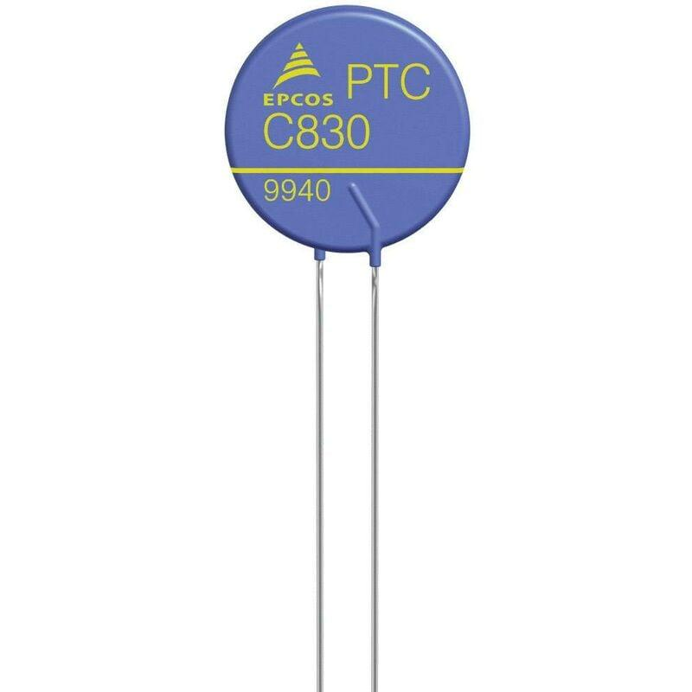

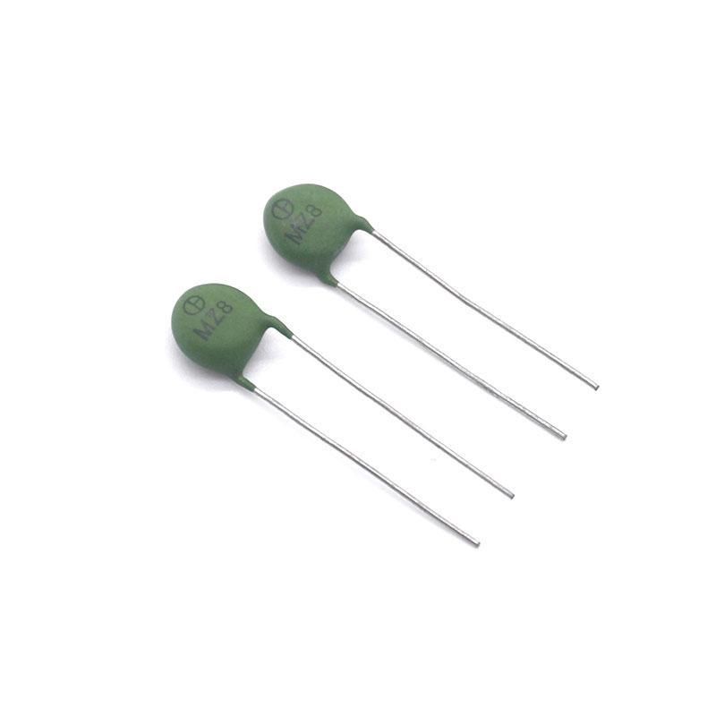
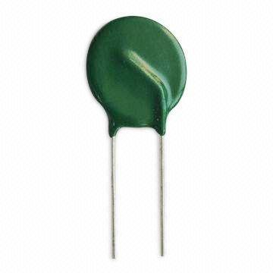
Description
Resistance increases as temperature increases.
Features
- Self-regulating
- Overcurrent protection
- Reliable safety device
Applications
- Motor protection
- Battery protection
- Overheating protection
- Circuit protection

3. Bead Thermistor
# Source: AI Source: Provided by: [Data Path: Persons Table -> ID Column: 1, Name_En Column: Motasem Essam] -> From: [ChatGPT] on [7/17/2026]


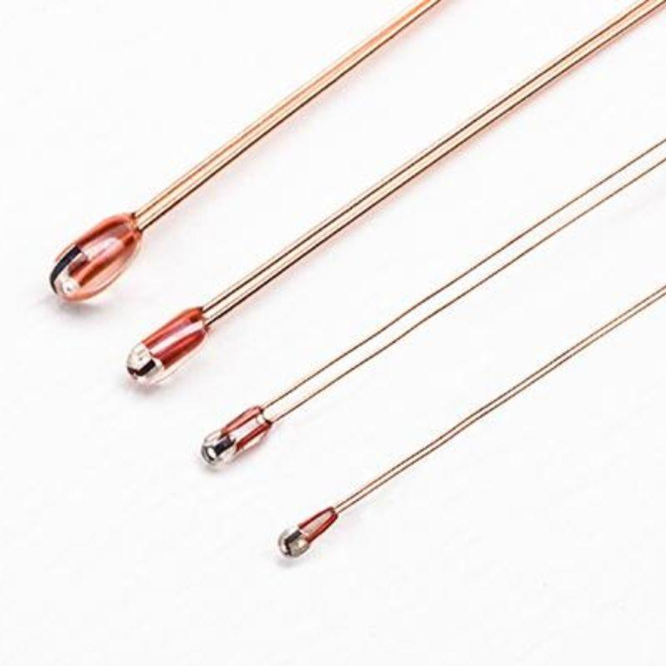
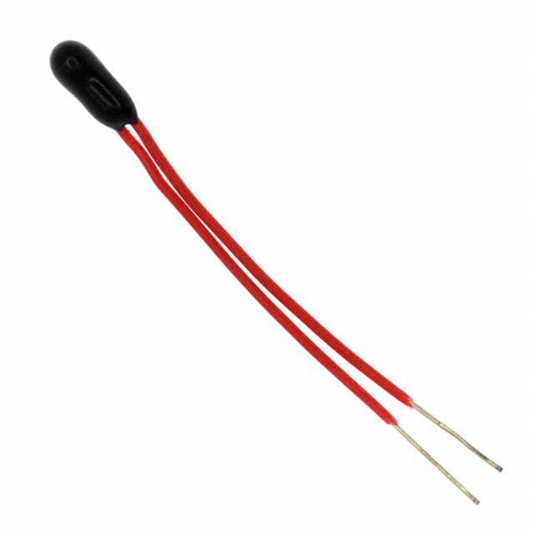
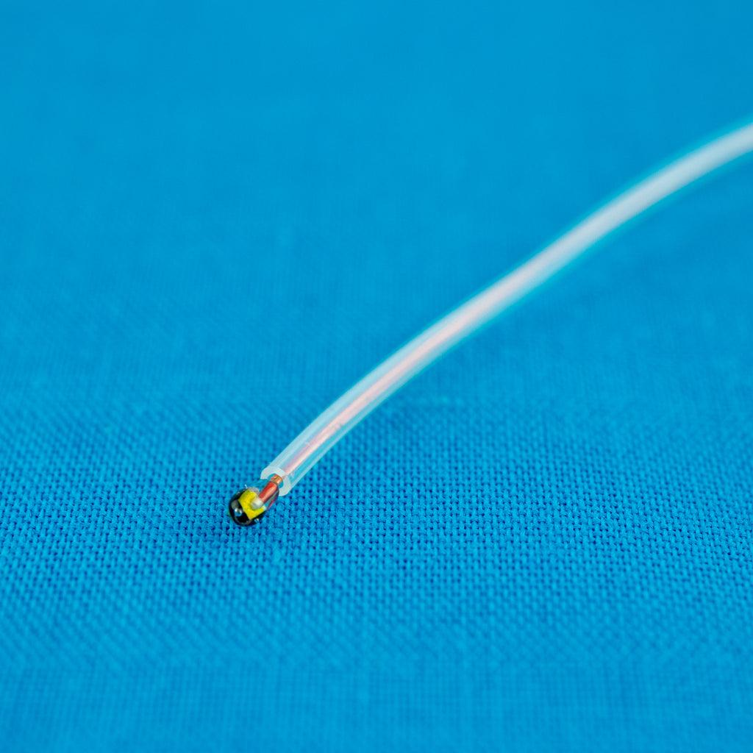
Description
Very small thermistor enclosed in a glass bead for rapid temperature response.
Applications
- Medical devices
- Scientific instruments
- Electronics

4. Probe Thermistor
# Source: AI Source: Provided by: [Data Path: Persons Table -> ID Column: 1, Name_En Column: Motasem Essam] -> From: [ChatGPT] on [7/17/2026]
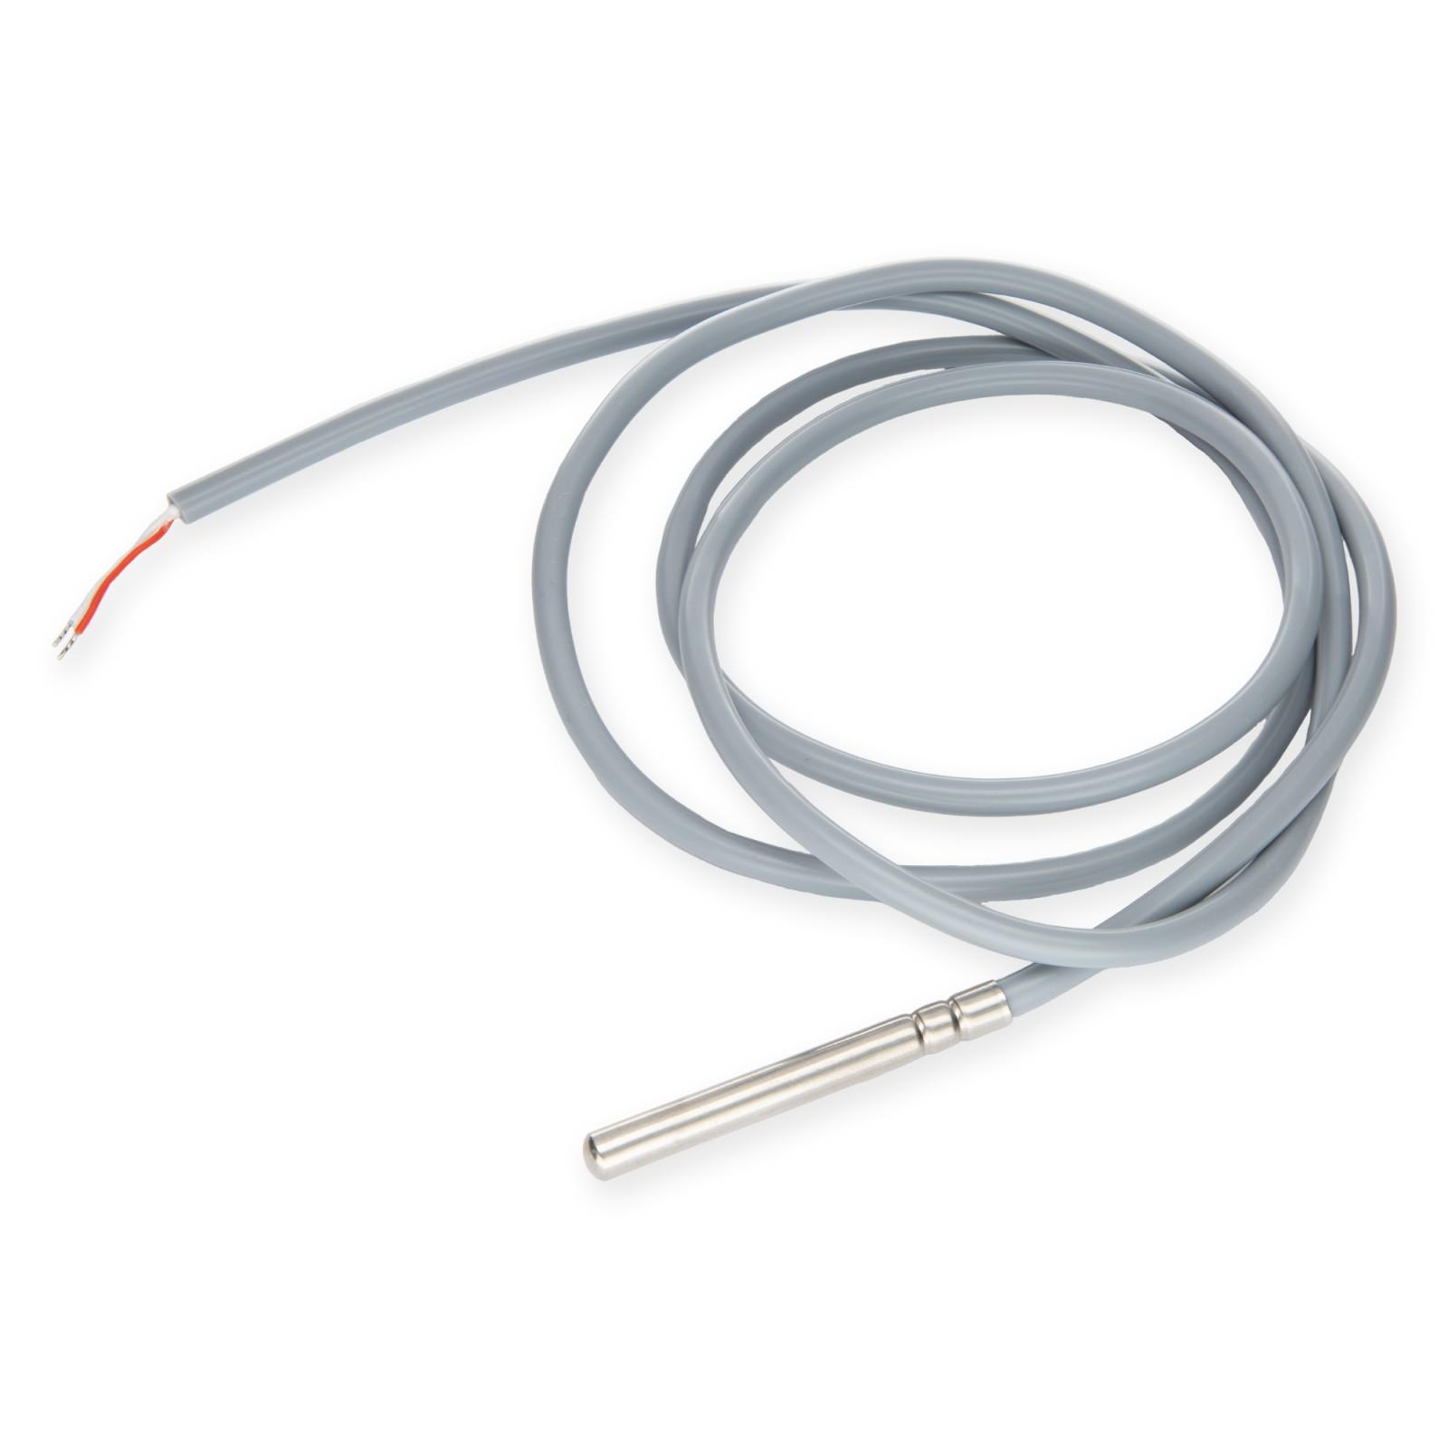
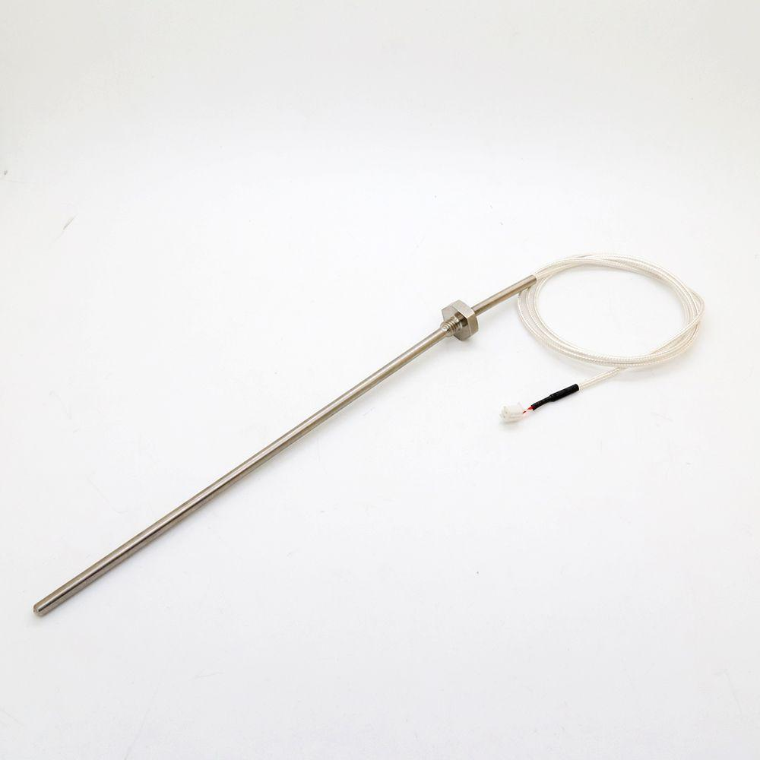

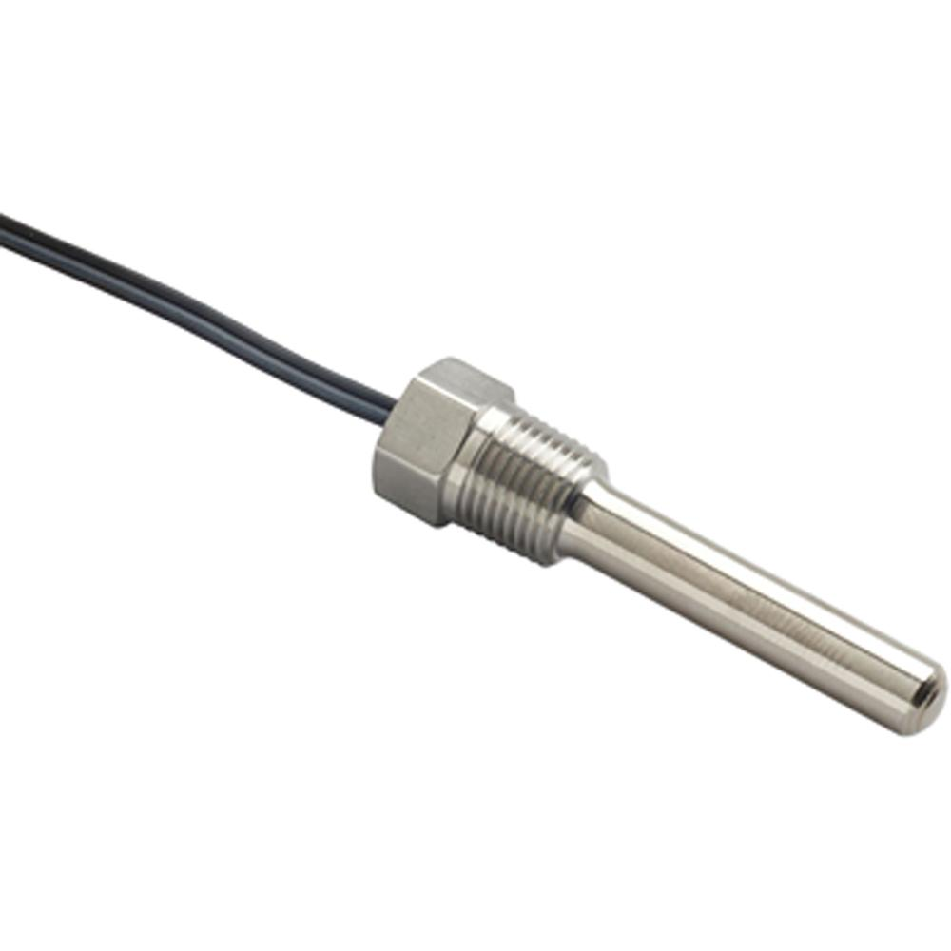

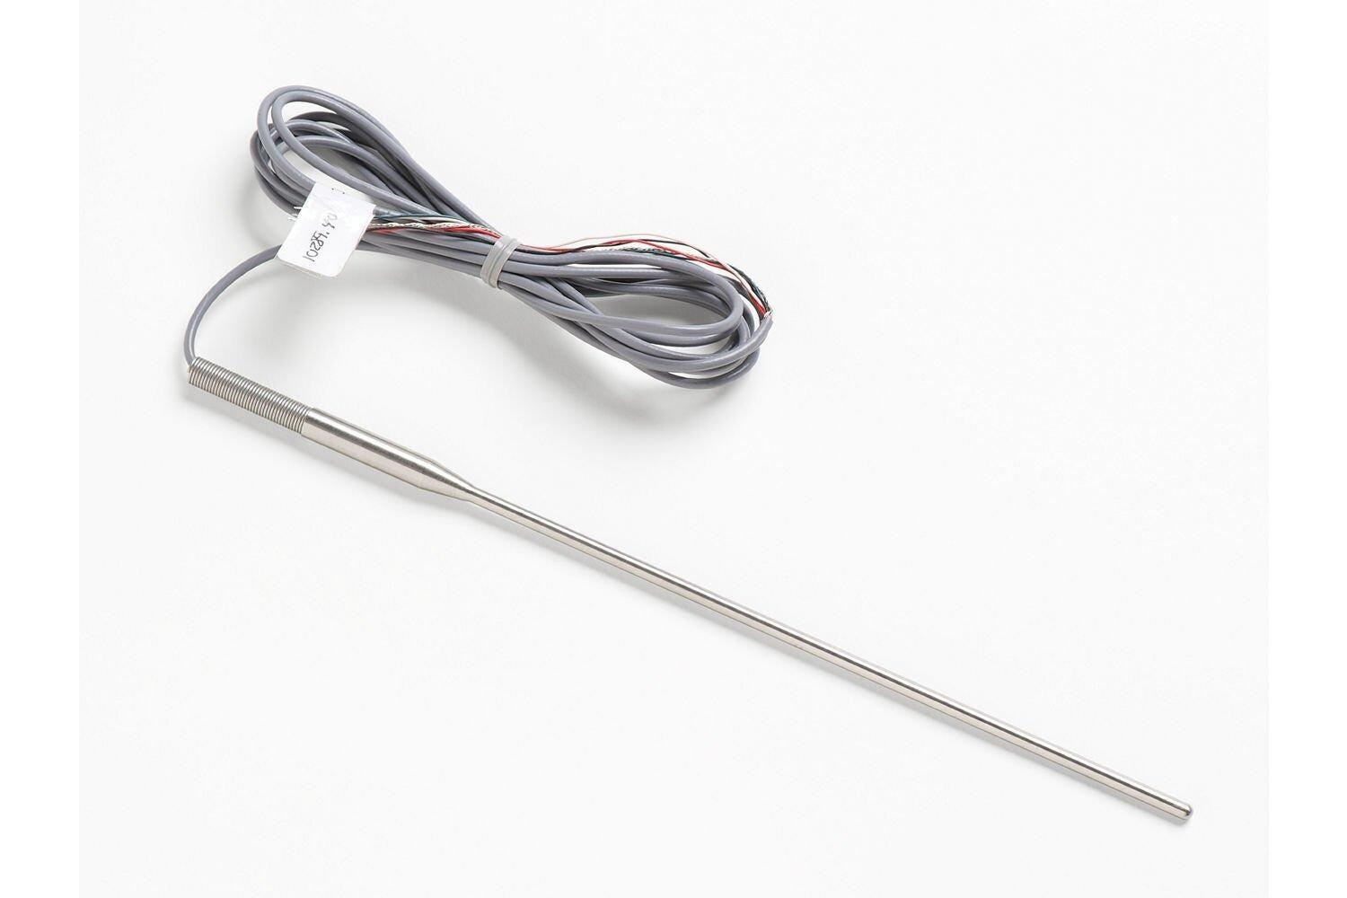
Description
Thermistor mounted inside a metal probe for measuring liquids, gases, or surfaces.
Applications
- Food processing
- HVAC
- Industrial temperature measurement

Measuring Units
# Source: AI Source: Provided by: [Data Path: Persons Table -> ID Column: 1, Name_En Column: Motasem Essam] -> From: [ChatGPT] on [7/17/2026]
Thermistors measure temperature in:
- Degree Celsius (°C)
- Kelvin (K)
- Degree Fahrenheit (°F)

Measuring Range
# Source: AI Source: Provided by: [Data Path: Persons Table -> ID Column: 1, Name_En Column: Motasem Essam] -> From: [ChatGPT] on [7/17/2026]
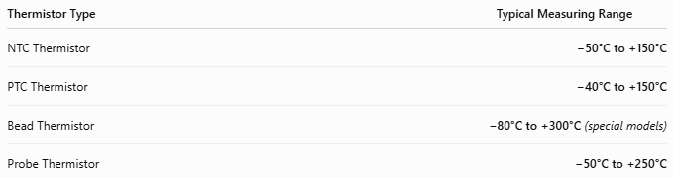
Thermistor Type | Typical Measuring Range
NTC Thermistor | −50°C to +150°C
PTC Thermistor | −40°C to +150°C
Bead Thermistor | −80°C to +300°C (special models)
Probe Thermistor | −50°C to +250°C

Resolution
# Source: AI Source: Provided by: [Data Path: Persons Table -> ID Column: 1, Name_En Column: Motasem Essam] -> From: [ChatGPT] on [7/17/2026]
Resolution depends on the measuring electronics connected to the thermistor.
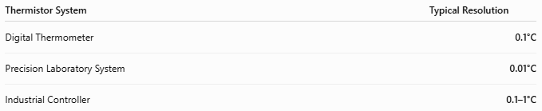
Thermistor System | Typical Resolution
Digital Thermometer | 0.1°C
Precision Laboratory System | 0.01°C
Industrial Controller | 0.1–1°C

Accuracy
# Source: AI Source: Provided by: [Data Path: Persons Table -> ID Column: 1, Name_En Column: Motasem Essam] -> From: [ChatGPT] on [7/17/2026]
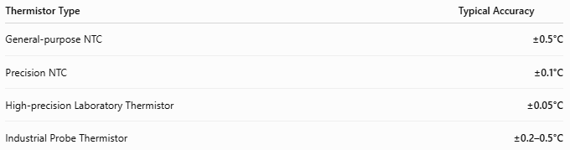
Thermistor Type | Typical Accuracy
General-purpose NTC | ±0.5°C
Precision NTC | ±0.1°C
High-precision Laboratory Thermistor | ±0.05°C
Industrial Probe Thermistor | ±0.2–0.5°C
Notes
- Thermistors provide excellent sensitivity over a relatively limited temperature range.
- They are generally more sensitive than thermocouples within their operating range.
- Accuracy depends on calibration, electronics, and environmental conditions.

How to Use a Thermistor
# Source: AI Source: Provided by: [Data Path: Persons Table -> ID Column: 1, Name_En Column: Motasem Essam] -> From: [ChatGPT] on [7/17/2026]
- Connect the thermistor to the measuring circuit.
- Place the sensor where temperature is to be measured.
- Allow the sensor to stabilize.
- Read the temperature from the display or controller.

Applications
# Source: AI Source: Provided by: [Data Path: Persons Table -> ID Column: 1, Name_En Column: Motasem Essam] -> From: [ChatGPT] on [7/17/2026]
Thermistors are used in:
- Digital thermometers
- Medical equipment
- HVAC systems
- Refrigerators
- Automotive engines
- Battery management systems
- Industrial automation
- Scientific instruments
- Consumer electronics

Advantages
# Source: AI Source: Provided by: [Data Path: Persons Table -> ID Column: 1, Name_En Column: Motasem Essam] -> From: [ChatGPT] on [7/17/2026]
A thermistor:
- Is inexpensive.
- Has very high sensitivity.
- Responds quickly.
- Is compact.
- Requires little power.

Limitations
# Source: AI Source: Provided by: [Data Path: Persons Table -> ID Column: 1, Name_En Column: Motasem Essam] -> From: [ChatGPT] on [7/17/2026]
A thermistor:
- Has a limited temperature range compared to thermocouples.
- Has a nonlinear resistance–temperature relationship.
- May require calibration for high-precision applications.

Sources of Error
# Source: AI Source: Provided by: [Data Path: Persons Table -> ID Column: 1, Name_En Column: Motasem Essam] -> From: [ChatGPT] on [7/17/2026]
Sensor Errors
- Aging
- Manufacturing tolerance
- Drift

User Errors
- Poor sensor placement
- Incorrect wiring
- Inadequate stabilization time

Environmental Errors
- Electrical noise
- Self-heating
- Moisture
- Thermal gradients

Comparison with Other Temperature Sensors
# Source: AI Source: Provided by: [Data Path: Persons Table -> ID Column: 1, Name_En Column: Motasem Essam] -> From: [ChatGPT] on [7/17/2026]
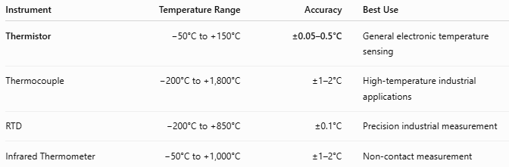
Instrument | Temperature Range | Accuracy | Best Use
Thermistor | −50°C to +150°C | ±0.05–0.5°C | General electronic temperature sensing
Thermocouple | −200°C to +1,800°C | ±1–2°C | High-temperature industrial applications
RTD | −200°C to +850°C | ±0.1°C | Precision industrial measurement
Infrared Thermometer | −50°C to +1,000°C | ±1–2°C | Non-contact measurement

Care and Maintenance
# Source: AI Source: Provided by: [Data Path: Persons Table -> ID Column: 1, Name_En Column: Motasem Essam] -> From: [ChatGPT] on [7/17/2026]
To maintain accuracy:
- Avoid excessive mechanical stress.
- Protect from moisture.
- Keep electrical connections clean.
- Calibrate periodically if high accuracy is required.

Common Mistakes
# Source: AI Source: Provided by: [Data Path: Persons Table -> ID Column: 1, Name_En Column: Motasem Essam] -> From: [ChatGPT] on [7/17/2026]
- Measuring outside the specified temperature range.
- Using the wrong thermistor type (NTC vs PTC).
- Ignoring self-heating effects.
- Poor thermal contact with the measured object.

Key Points
# Source: AI Source: Provided by: [Data Path: Persons Table -> ID Column: 1, Name_En Column: Motasem Essam] -> From: [ChatGPT] on [7/17/2026]
- A Thermistor is a temperature sensor, not a mass or weight instrument.
- It measures temperature through changes in electrical resistance.
- Main types:
  - NTC Thermistor
  - PTC Thermistor
  - Bead Thermistor
  - Probe Thermistor
- Common applications include medical devices, HVAC, automotive systems, consumer electronics, and industrial control.

Conclusion
# Source: AI Source: Provided by: [Data Path: Persons Table -> ID Column: 1, Name_En Column: Motasem Essam] -> From: [ChatGPT] on [7/17/2026]
A Thermistor is a highly sensitive electronic temperature sensor that measures temperature by monitoring changes in electrical resistance. Its excellent sensitivity, rapid response, compact size, and low cost make it one of the most widely used temperature-sensing devices in medical equipment, household appliances, automotive systems, industrial automation, and scientific instrumentation.

